**INTRODUCTION / BUSINESS PROBLEM:**

I will be relocating my family from Dallas to Toronto. My wife and I like to eat out regularly and try new restaurants. In New York we have a lot of options and cuisines from across the world. We do not have any friend or family in Toronto and are not familiar with the city. We really enjoy eating Nepalese food, Chinese food and Korean food. I would like to compare these two cities and determine if we can easily enjoy the types of food we can enjoy in Dallas.

**DATA:**

I will use Wikipedia to get the Postal Code, boroughs and neighborhoods in Toronto. I will use Foursquare location data to filter out the locations in Toronto and identify what are my choices for restaurant there. My second filter will be if these restaurants have Nepalese, Chinese and Korean options.

**METHODOLOGY:**

Several postal codes have boroughs and neighborhoods as “Not Assigned”. I removed these rows and grouped the data by postal code. I got longitudes and latitudes for the neighborhoods and merged it with the data frame with postal code, borough and neighborhood names. I also created a map of Toronto with the neighborhoods marked with blue circles.

**FINDINGS AND OBSERVATIONS:**

I found out several neighborhoods that have diverse restaurants that my wife and I would like. 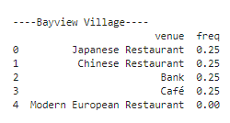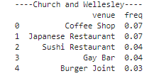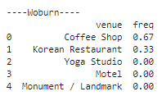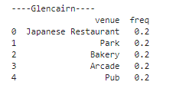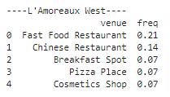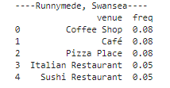

The above-mentioned neighborhoods have interesting eating options. Scarborough is the borough that has Indian Restaurant, Vietnamese Restaurant and Chinese Restaurant as most frequent venues. I would like to look for apartments in the neighborhoods of Scarborough.